Cure*All:* Closing Inequities in Childhood Cancer

Ji In Kim, RN, Rebekah Levine Coley, PhD, Philip J. Landrigan, MD, Boston College

Yoorim Bang, PhD, & Eunhee Ha, MD,[1] Ewha Womans University

CureAll is a framework to success to close childhood cancer inequities and improve survivorship across the globe. This global initiative is to be strongly considered by policy makers in lower- and middle-income countries (LMICs), where there is an immense need to combat childhood cancer.

## **The Need: Global Childhood Cancer Inequity Poses Huge Threats to Survivorship**

Each year more than 400,000 children and adolescents under age 20 are diagnosed with cancer. This translates into a new diagnosis of childhood cancer every 3 minutes.1 Between 2020 and 2050, it is estimated that there will be 13.7 million new cases of childhood cancer globally.2 At current levels of health system performance, 6.1 million (44.9%) of these children will go undiagnosed.2 And without further improvements in access to diagnostic and treatment healthcare services, 11.1 million children will die from cancer between 2020 and 2050, with 9.3 million (84.1%) of these deaths occurring in LMICs.2

Cancer does not discriminate; it affects children across the globe. Overall, childhood cancer is under-recognized and hence under-treated. But there are significant national inequities, with child cancer diagnoses and net survivorship varying greatly across geographical location, as seen in Figure 1.1 Importantly, 9 of 10 children diagnosed with cancer live in LMICs where the survival rate of 30% is dramatically lower than the survival rate of >80% in high income countries.1

***Figure 1: Estimated Childhood Cancer 5- Year Net Survival by Country (2015-2019*)**

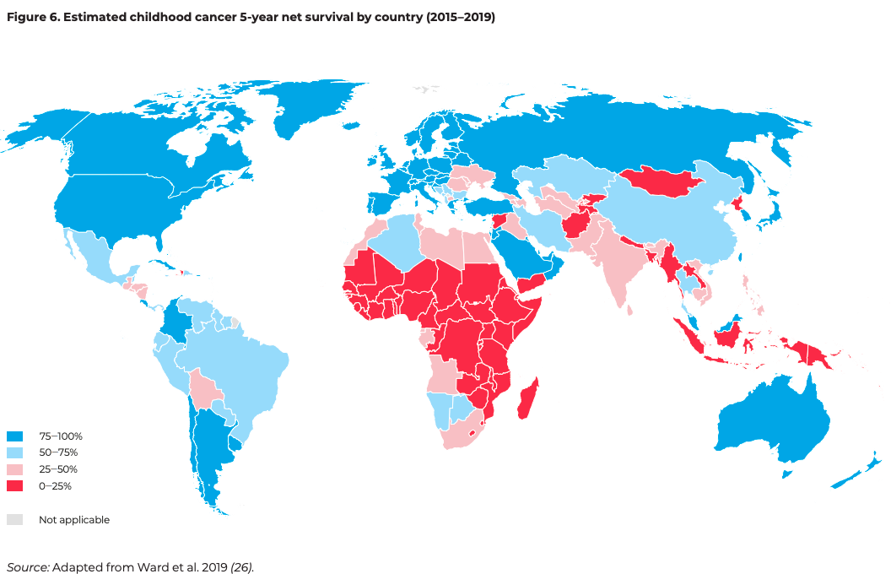

From the World Health Organization (2020)1

These stark disparities in childhood cancer diagnoses and survival underscore the urgent need to address existing gaps in LMICs at the policy level to improve rates of childhood cancer survivorship. Late diagnosis and limited access to effective treatment are more prevalent in LMICs, which impact cancer survivorship. For instance, 66% of 8,000 children diagnosed annually with retinoblastoma are in LMICs, with 90% of cases presenting at advanced stages.3 Additionally, 50-60% of children in LMICs refuse or abandon therapy, hindering long-term treatment and survival outcomes. These challenges are further compounded by inequities in access to and affordability of care, driven by socioeconomic, cultural, and psychosocial factors.3 A lack of public awareness, financial barriers to accessing and continuing care, insufficient healthcare providers, and limited diagnostic infrastructure continue to contribute to high mortality rates in LMICs.3 Early diagnosis and timely referrals to appropriate multidisciplinary care, effective in improving survival rates in high income countries (HICs), must be prioritized through targeted policy interventions to reduce mortality and improve outcomes in LMICs.3

## **Cure*All*: A Framework to Increase Countries’ Capacity to Provide Quality Services for Children with Cancer**

“Too many children have their lives cut short by cancer, and survival rates in poor countries are scandalously lower than those in wealthy countries.”

- Dr. Tedros Adhanom Ghebreyesus, WHO Director-General

In September 2018, the World Health Organization and partners launched the Global Initiative for Childhood Cancer (GICC) in 10 pilot countries (Ghana, Morocco, Myanmar, Peru, the Philippines, Senegal, Sri Lanka, Ukraine, Uzbekistan, and Zambia), expanding after a 5-year review to over 70 countries.1 The GICC advances the goal of increasing childhood cancer survival rates from the global average of 40% to at least 60% by 2030, thereby saving the lives of 1 million children.1 The GICC initiative created the Cure*All* framework (Figure 2) to provide concrete approaches to increase a country’s capacity to provide quality services for children with cancer and prioritize childhood cancer nationally, regionally, and globally.1

Investing in childhood cancer programs reduces economic costs and mortality rates, which in turn promotes economic growth, workforce participation, and human capital.2 The Lancet Oncology Commission found that investing in coverage and quality of care could avert 6.2 million childhood cancer deaths, generating global lifetime productivity gains of $2,580 billion between 2020 to 2050. This is equivalent to a return of $3 for each $1 invested.2

***Figure 2: WHO Goal, Objectives, Outputs, Activities, & Approach for the Global Initiative for Childhood Cancer (GICC)***

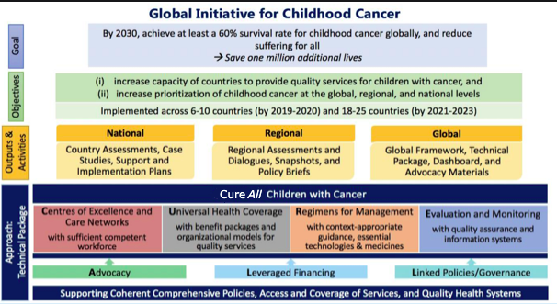

Adapted from the World Health Organization (2020)1

## **Implementing Cure*All* in non-participating LMICs and HICs**

To reach the GICC goals of increasing childhood cancer survivorship, nations, in particular those with the highest cancer mortality rates, are urged to implement the Cure*All* framework through the following strategies:1

* Identify gaps and formulate needs
* Collaborate and build cross-sectoral coalitions with external partners
* Generate data to inform ongoing decision-making
* Formulate policy and strategic plans specific to the focus country
* Enact levers or tools for implementing policy (i.e. design of health system organizational structures, legislations and regulation, standard-setting, incentives, enforcement and sanctions, and accreditation)
* Ensure accountability through (1) government structures, policies, and processes for health sector organizations; (2) mechanisms for independent oversight; and (3) openness to scrutiny by political representatives and civil society
* Implement evaluation, feedback, and refinement of policies

Implementing the Cure*All* framework in non-participating nations can help achieve the GICC goals of attaining substantively higher survival rates for children with cancer nationally and globally.

### **References**

1. *CureAll Framework: WHO Global Initiative for Childhood Cancer. Increasing Access, Advancing Quality, Saving Lives* (1st ed). (2021). World Health Organization.

2. Atun, R., Bhakta, N., Denburg, A., Frazier, A. L., Friedrich, P., Gupta, S., Lam, C. G., Ward, Z. J., Yeh, J. M., Allemani, C., Coleman, M. P., Di Carlo, V., Loucaides, E., Fitchett, E., Girardi, F., Horton, S. E., Bray, F., Steliarova-Foucher, E., Sullivan, R., … Rodriguez-Galindo, C. (2020). Sustainable care for children with cancer: A Lancet Oncology Commission. *The Lancet Oncology*, *21*(4), e185–e224. https://doi.org/10.1016/S1470-2045(20)30022-X

3. Rodriguez-Galindo, C., Friedrich, P., Morrissey, L., & Frazier, L. (2013). Global challenges in pediatric oncology. *Current Opinion in Pediatrics*, *25*(1), 3–15. https://doi.org/10.1097/MOP.0b013e32835c1cbe

1. Authors acknowledge the support from Eun Mi Jung, Logan G Spector, Byungmi Kim in the creation of this brief.