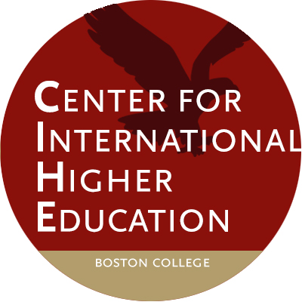

Visiting Scholar Application Form

First Name:

Last Name:

Mailing Address:

Mailing Address:

City:

State: Province: Zip Code:

Country:

Email address:

Current title and institutional affiliate:

Country of citizenship:

Highest level of education:

Gender:

Proposed dates of stay at Boston College:

Will you require a visa? YES NO

Please tick the boxes to confirm your understanding of the following statements:

1) I understand that, if approved as a CIHE visiting scholar, I will not receive any remuneration or other financial support from Boston College. I also understand that I am responsible for my own travel arrangements and for securing - and paying for - my own accommodations in Boston.
2) (If relevant) I understand that I am not entitled to any formal doctoral supervision during my time at CIHE.

3) I understand that I will be asked to pay a one-time $350* fee to the Center for International Higher Education to offset the administrative costs associated with the visiting scholar program.

*this fee may be pro-rated if stay is less than one semester in length.

